**TOP Future Technologies 2022**

Technologies is Ever- evolving, from a last some past years as we have seen the incredibly growth in technology in many fields ,either it is Medicine, healthcare, Artificial Intelligence(AI), blockchain and many more. These technologies are transforming our lives today.

So in future we also see these types of Technologies:-

* **Edge Computing**:- Edge computing is a current technology development that brings data storage and computation closer to business improving reaction time and reducing bandwidth uses. It is also consider to be the most recent technology strength because enterprises are rapidly gaining access to Sophiscated and specialized resources which ensures reduces leniency. Edge computing secures to new high by local compliance privacy legislation and data sovereignty concerns. Although many people feel that edge computing increases attacks services. it really reduces the influence of an enterprises. Other benefits of edge computing includes enhanced speed and reduce costs. Top tier companies like DELL, AWS, Google cloud platform, HPE and IBM etc are ready to adopt edge computing.

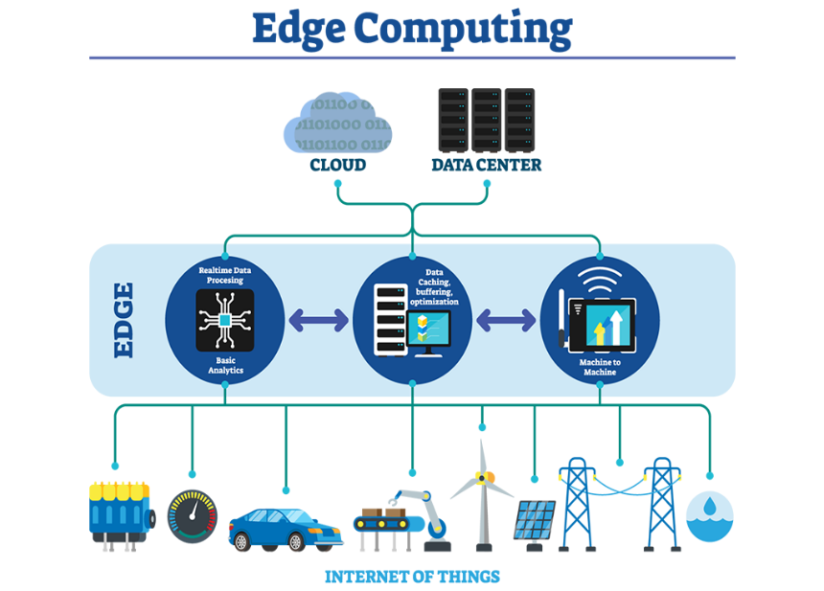

* **Human Augmentation-** Human Augmentation techniques enhancing the person physical and cognitive abilities is known as Human Augmentation.

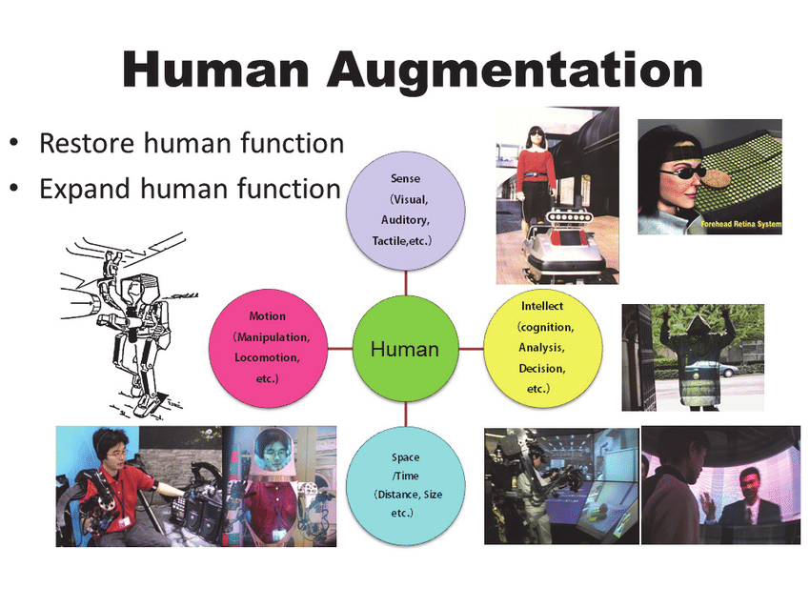

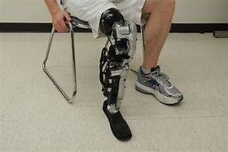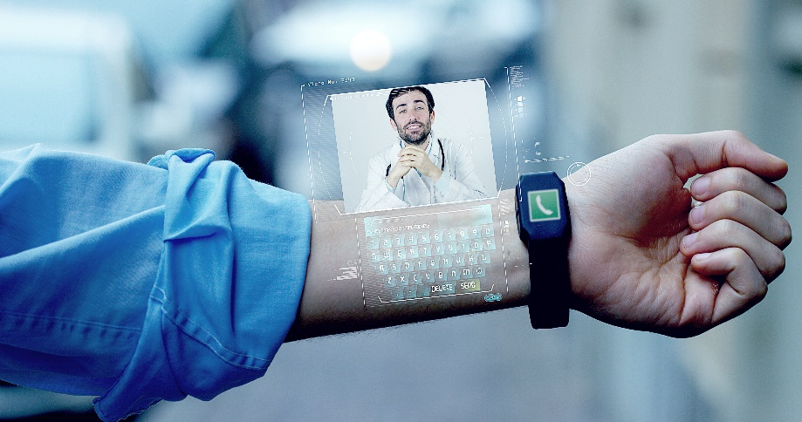

Once planted in a person it will allow them to perform activities that previously impossible. Human Augmentation is one of the most recent technology advancement in a post modern age would not only improve the human physical endurance but also their ability to think and make better decisions. It has lot of promising in technology.

* **AI or Artificial Intelligence**:- It has proven one of the most transformative tech evolutions. However, the current world scenarios it seems the most useful technology and promising technology in todays world. Some AI technology like ALTEREGO- a mind -reading wearable and citizen robos like Sophia are indicator how AI become most highly effective technology in incoming years. Domicopter Test delivery has been already tested by some companies Dominos and Doordash.

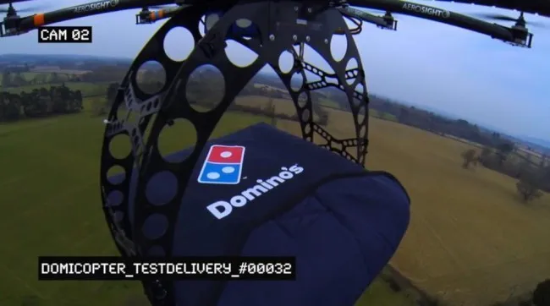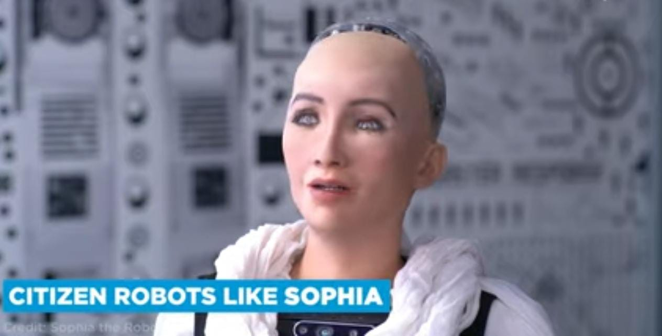

Despite that these technology are still riddled with flaws that threat to human safety. AI technology is become technological trend in the future by giving it more potential. Companies like NVIDIA, Google , Microsoft has been adopted artificial intelligence in some way or other.

* **Quantum Computing**- It is design to resolve difficulties simply its still comes at a cost by superimposing and entanglement . These computer explore quantum mechanics to address difficulties. It has ability to analyze and act in data, regardless of the source. Another field where quantum computing is finding is banking and finance, to manage credit risk, for high- frequency trading and fraud detection.

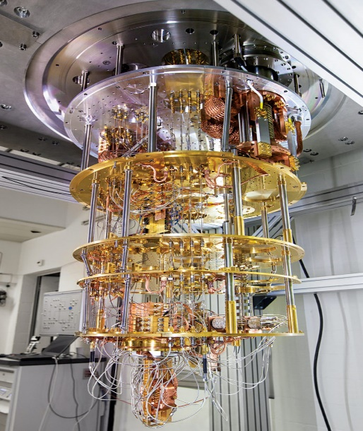

* **Computer Vision**- It is a branch of artificial intelligent the allows the computers to extract the important information from digital photos, videos and other visual inputs as well as conduct actions or make recommendation based on that data. AI has made significant try in recent years to passing human in several task relating to object detection and classification. Thanks to BREAKTHROUGHS in artificial intelligence and innovation in deep learning and neural networks.

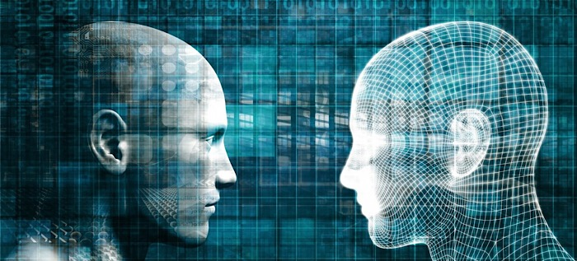

Computer vision is employed variety of industries including energy and utilities , manufacturing and automotive and industrial growing. By 2022 it may reached $ 48.6 Billion . The most popular computer vision companies includes TRACTABLE, VERKADA, HAWK-EYE among others.

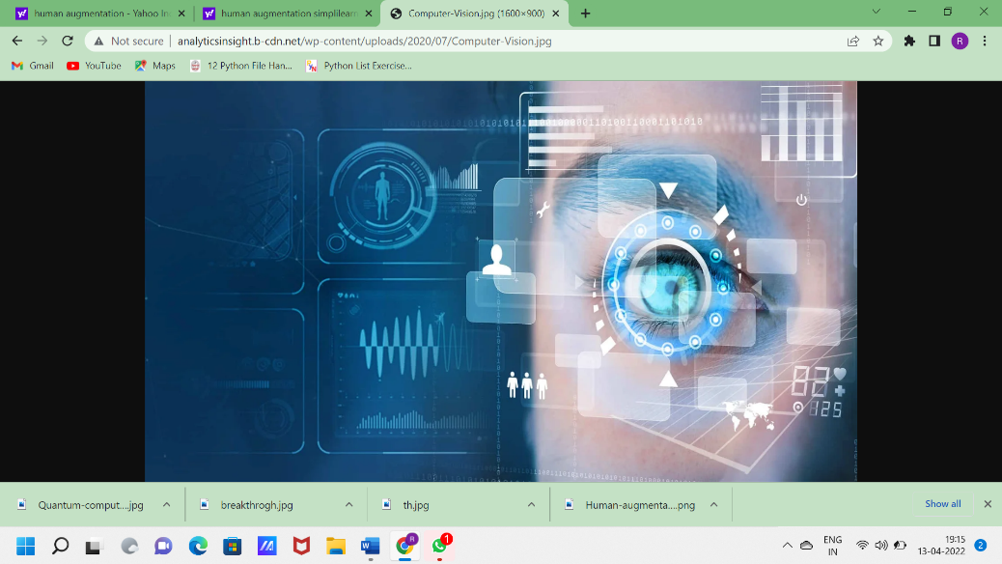

* **Digital Twin** : It is a virtual representation of physical objects that is designed to exactly reflected. The object and investigation is include variety of sensors. These sensors collect data on the energy production, temperature, weather condition and other objects characteristics of the physical performance. This information is subsequently send to processing machine where its’s apply to a digital copy. This technology is used for building, manufacturing plants, cars or any complex objects to monitor. This will assist in a transformation of numerous processes as well as detection potential future breakdowns, events and abnormalities in their functioning. Companies like Microsoft, siemens, oracle. IBM, CISCO among the other top tier company used the technology digital twin.

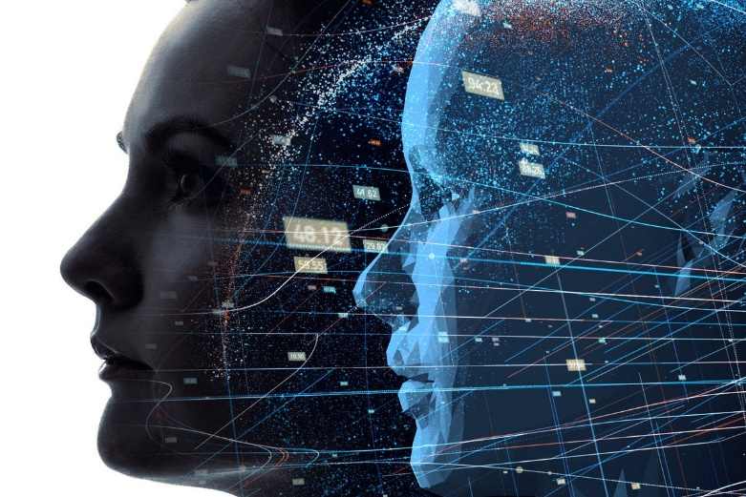

* **Intelligence process Automation (IPA)** - Intelligence process Automation is use Artificial Intelligence and related emerging technologies to robotics process such as computer vision, cognitive automation, machine learning. According to McKinsey & company in several industries that have experimented with Intelligence process automation have achieved impressing results with the automation of about 50 to 70% of tasks, 25 to 30% annual cost reduction and ROI in triple- digit %. Its safe to say the benefits of Intelligence process Automation is a significant implications of the returns amplification of the returns RPA offers companies like CAPGIMINI, IBM, Deloitte, SAP etc are reading deploying Intelligence process Automationtheir organization.

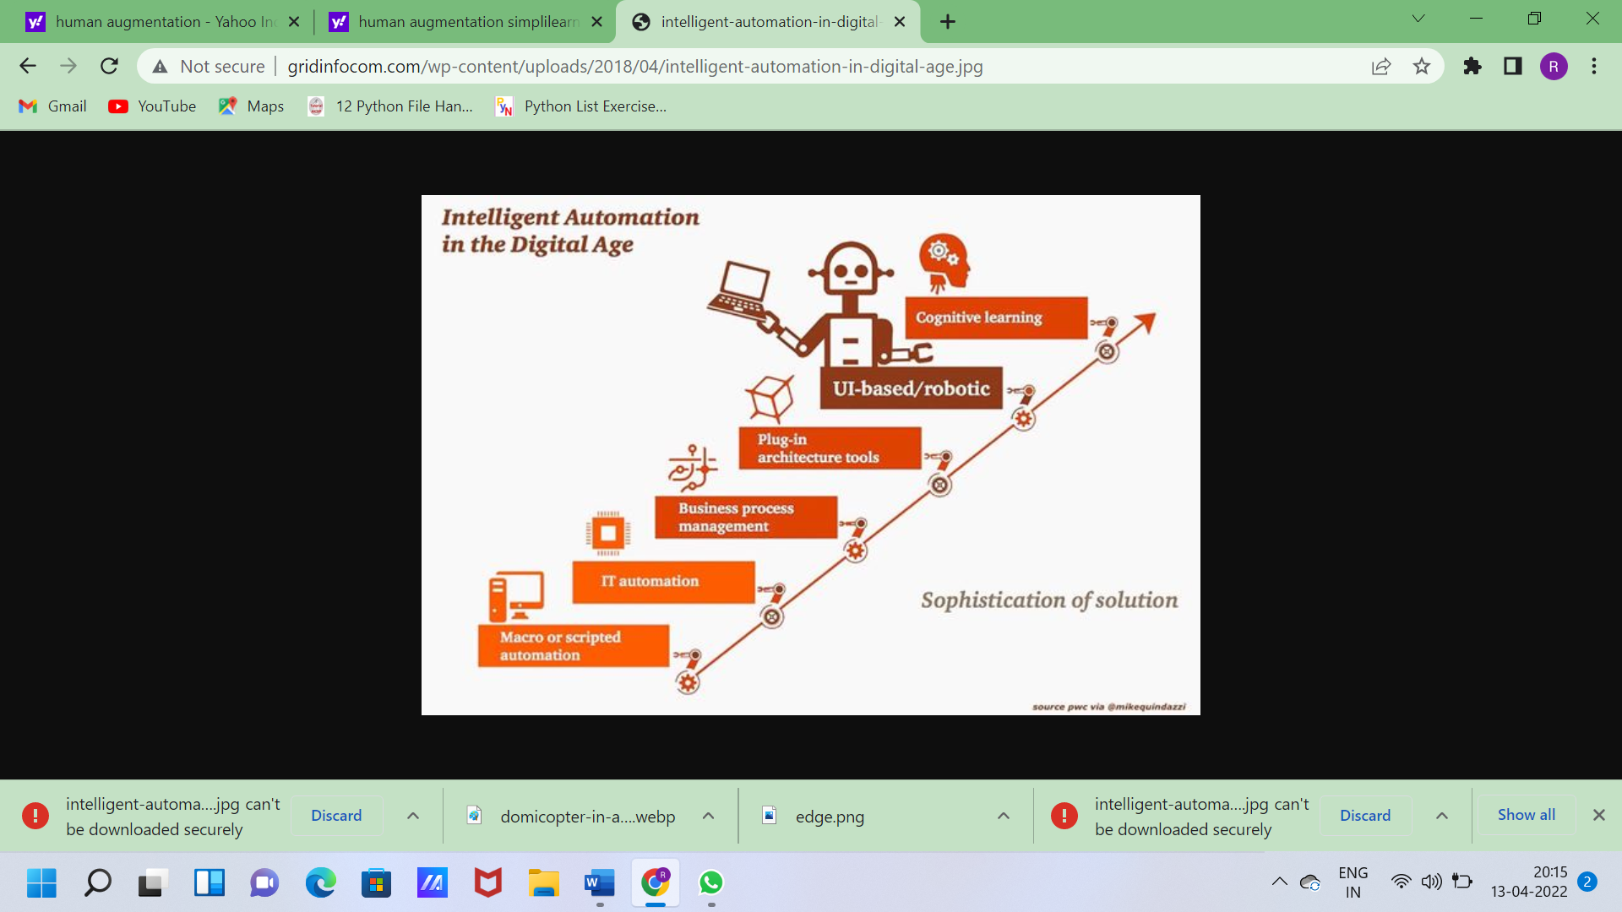

By Ruchi Gunjan Sinha

MCA 1St year